Assignment 24.6:

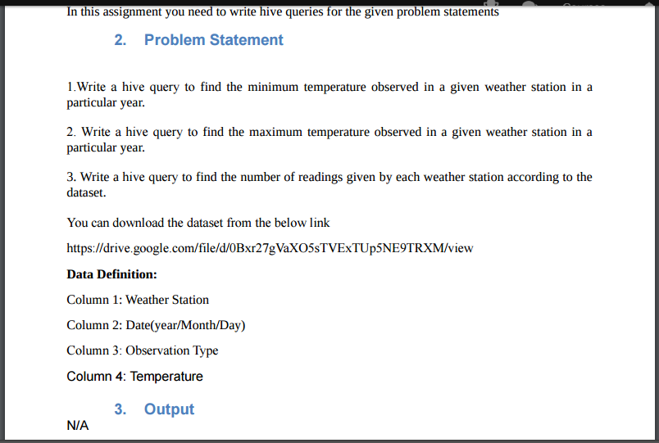

I created a table named temperature with columns weather station, date and temperature. And then the data is loaded into the table and displayed the contents of the table.

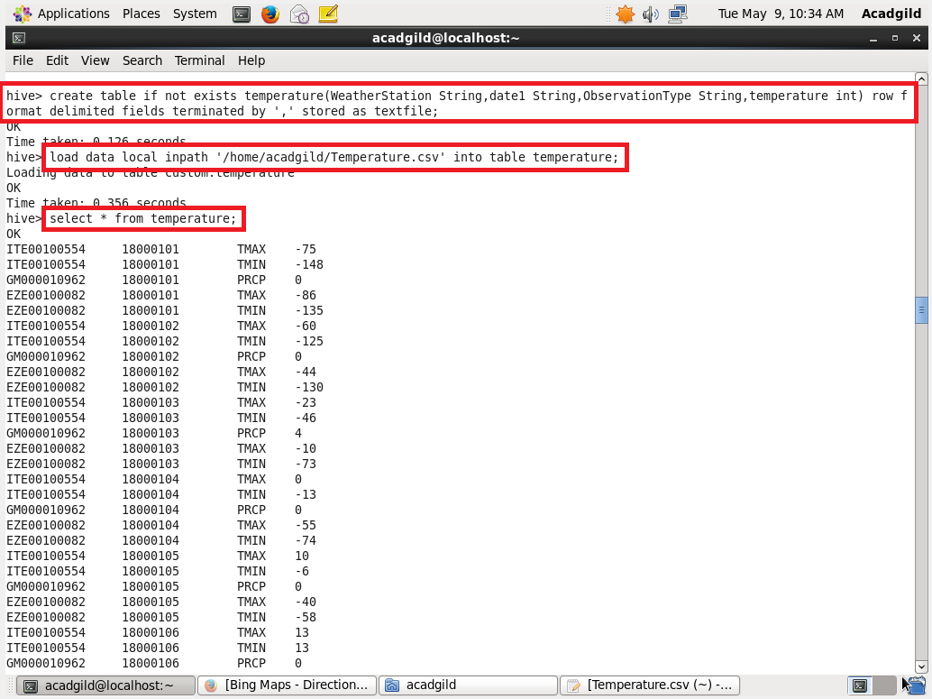

1. Write a hive query to find the minimum temperature observed in a given weather station in a particular year.

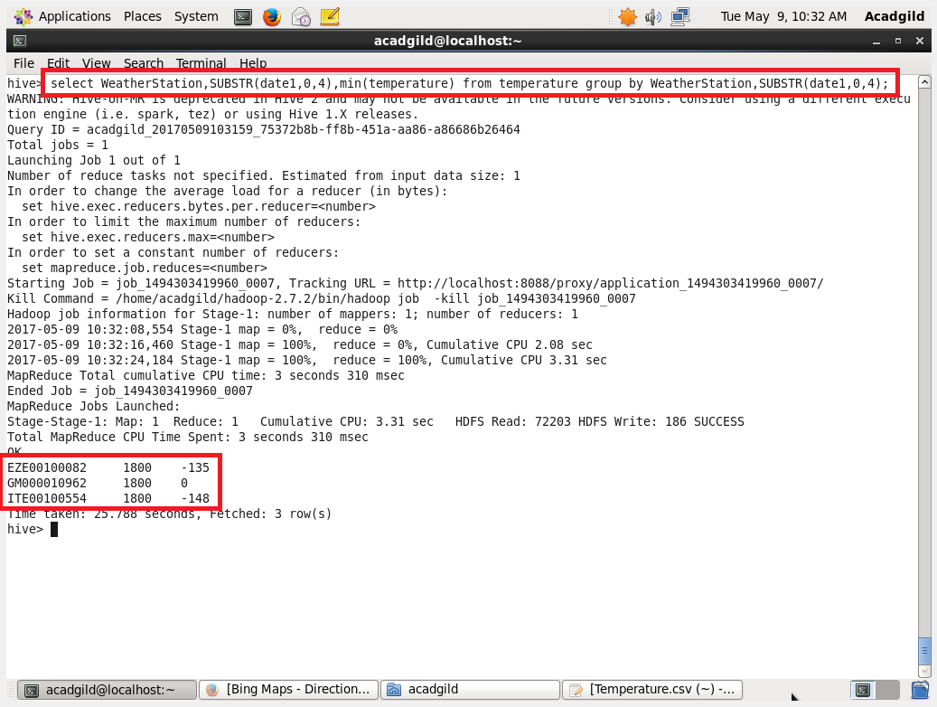

2. Write a hive query to find the maximum temperature observed in a given weather station in a particular year

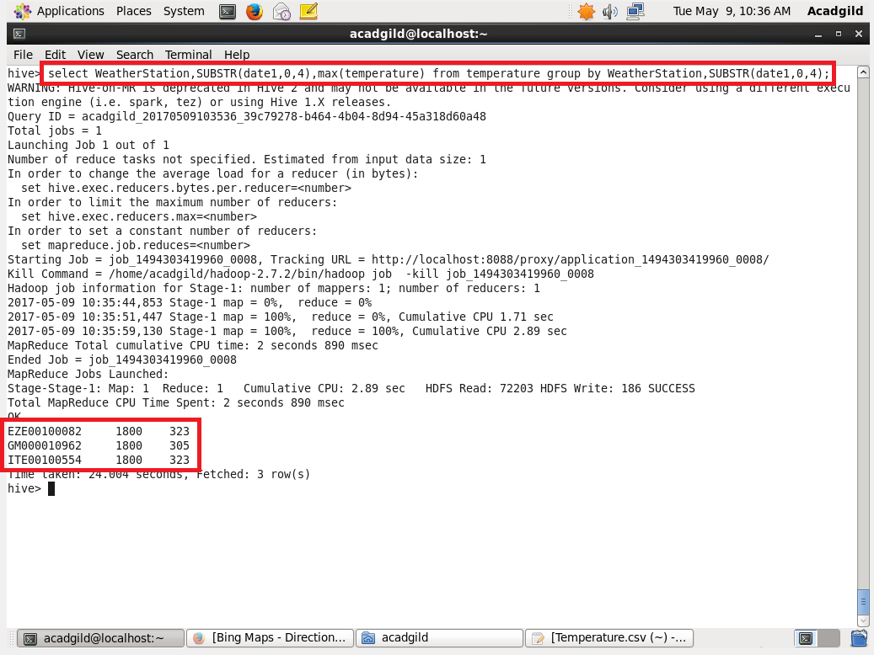

3. Write a hive query to find the number of readings given by each weather station according to the dataset.

